**Exercise 1: Setting Up Junit**

**Scenario:** You need to set up JUnit in your Java project to start writing unit tests

**Steps:**

1. Create a Java or Maven project. I have created a Maven project.
2. Add the below JUnit dependency in your pom.xml

<dependency>

<groupId>junit</groupId>

<artifactId>junit</artifactId>

<version>4.13.2</version>

<scope>test</scope>

</dependency>

1. Create a class file in src/main/java. Ex – Calculator.java
2. Create a Junit Test Case file in src/test/java. Ex – CalculatorTest.java
3. Test the class with the values if a ‘Green’ bar is showed then the test case is a success. If a ‘Red’ bar shows then the test case is a failure.

**Code:**

*Calculator.java -*

package com.example.junit;

public class Calculator {

public int add(int a, int b) {

return a + b;

}

}

*CalculatorTest.java –*

package com.example.junit;

import static org.junit.Assert.*;

import org.junit.Test;

public class CalculatorTest {

@Test

public void test() {

Calculator calc = new Calculator();

int result = calc.add(2, 3);

assertEquals(5, result);

}

}

*Pom.xml –*

<project xmlns="http://maven.apache.org/POM/4.0.0" xmlns:xsi="http://www.w3.org/2001/XMLSchema-instance" xsi:schemaLocation="http://maven.apache.org/POM/4.0.0 https://maven.apache.org/xsd/maven-4.0.0.xsd">

<modelVersion>4.0.0</modelVersion>

<groupId>com.example</groupId>

<artifactId>junitdemo</artifactId>

<version>0.0.1-SNAPSHOT</version>

<dependencies>

<dependency>

<groupId>junit</groupId>

<artifactId>junit</artifactId>

<version>4.13.2</version>

<scope>test</scope>

</dependency>

</dependencies>

</project>

**OUTPUT: (Screenshots)**

* **TEST CASE PASSED**

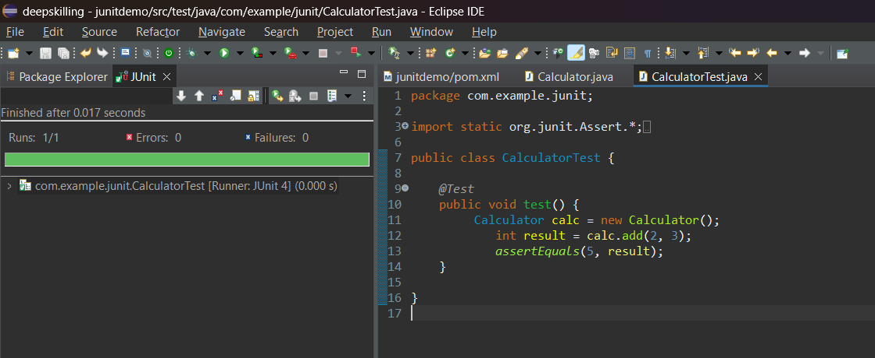

* **TEST CASE FAILED**

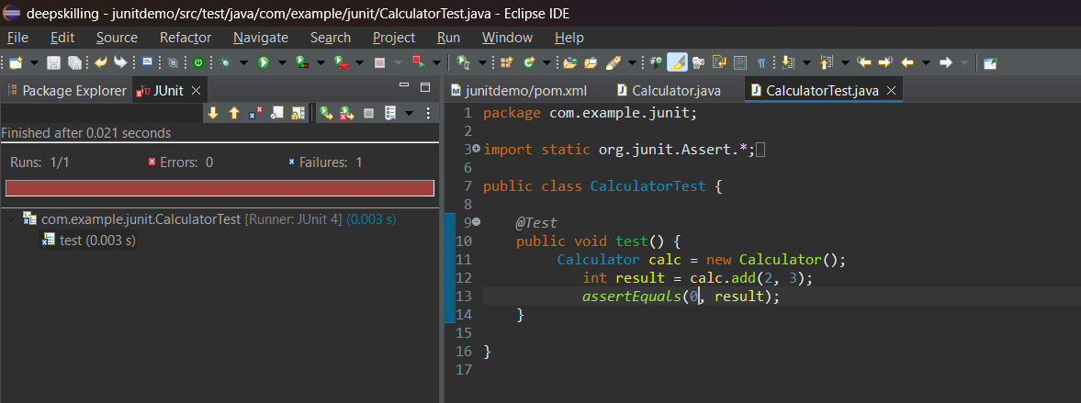

**PROJECT STRUCTURE –**

